Assignment 5.2
Robert Breutzmann's CSD340 GitHub
Robert Breutzmann's GitHub Pages Landing Page
Subject Name: Joshua Blomgren

Interview
Note: The interview took place on Facebook Messenger, so I copied/pasted the conversation and formatted it for this. I also shortened and edited out some of the “blurbs” that were not pertinent to the inquiry.
• How did you first get started in blacksmithing, and what made you want to try it for yourself instead of just watching or reading about it?
• What kinds of things do you enjoy forging the most, and why do those projects stand out to you?
• Can you walk me through what a typical day at the forge looks like for you, from start to finish?
• What part of the blacksmithing process do you find the most satisfying, and what part do you find the most challenging?
• How has blacksmithing changed the way you think about work, patience, or craftsmanship?
• Growing up, were there experiences or influences that pushed you toward working with your hands or making things?
• You were diagnosed with Asperger’s. In what ways do you think that influences how you learn or practice blacksmithing?
• Are there aspects of forging that feel especially calming or grounding for you? If so, what about them helps?
• What accomplishments in blacksmithing are you most proud of so far, even if they seem small to others?
• Looking ahead, what do you hope blacksmithing becomes in your life over the next few years?

Bio

Images

Profile Picture. Josh, in his forge, with his forging apron on, illuminated by the fire of the forge.

Accomplishments

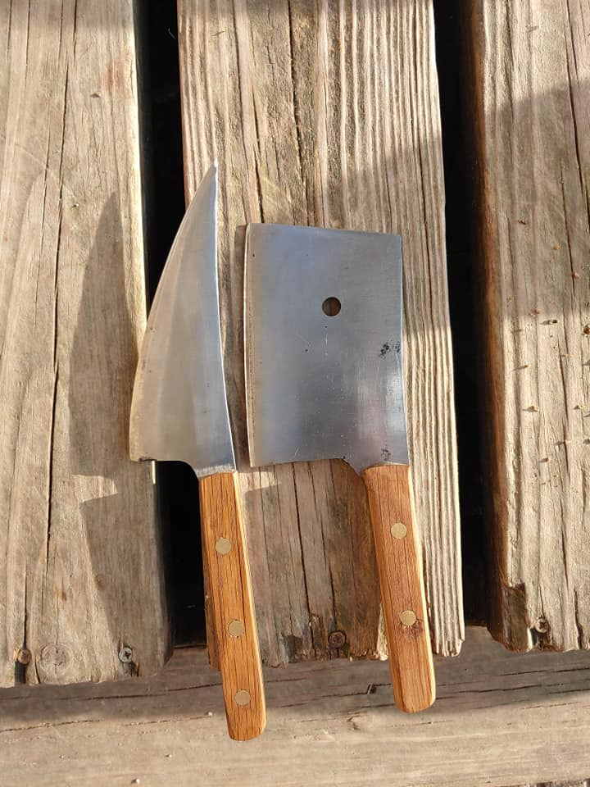
Some of Josh’s first creations

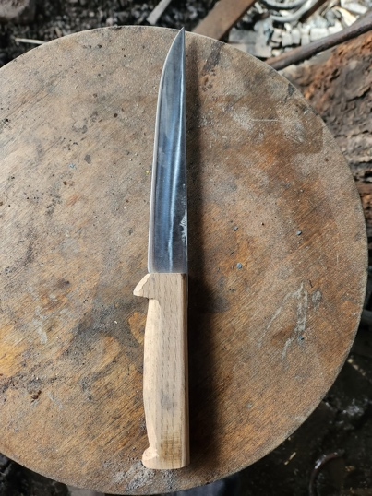
A more polished Knife, one of the first Josh sold
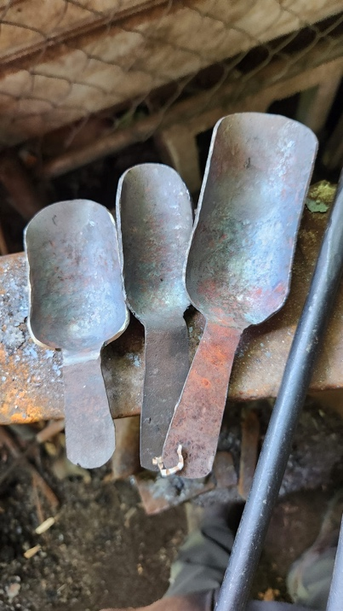
Some scoops Josh made, for practical purposes, around the house.

Hobbies-Stock Photos

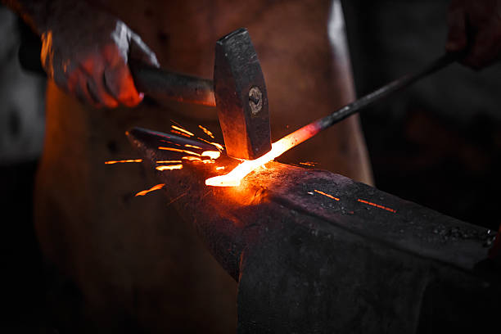
Stock image (iStock) of a blade being hammered on an Anvil.

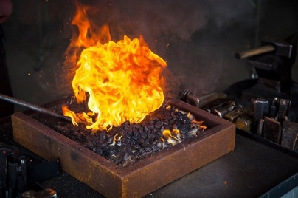
Stock image (iStock) of a blade in a forge.

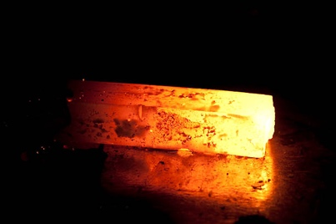
Stock image (iStock) of a piece of molten steel, ready to be shaped.

Style Guide:

1. Design Direction & Rationale
The visual direction of this site is inspired by blacksmithing as a craft: strong, grounded, functional, and timeless. The design emphasizes structure, clarity, and intentional simplicity. Decorative elements are minimal, so the focus remains on Joshua’s work, process, and story. The overall aesthetic reflects durability, focus, and precision rather than trends or visual noise.

2. Color Palette
The color palette draws inspiration from the forge environment: steel, fire, and earth.
Primary Colors
- Charcoal Black – #1F1F1F
Primary background color. Represents iron, strength, and focus.
- Forged Steel Gray – #4A4A4A
Secondary background and structural elements such as headers or footers.
Accent Colors
- Forge Orange – #C65A1E
Accent color used sparingly for buttons, links, or highlights. Represents heat and fire.
- Warm Ash – #D8D2C8
Used for section backgrounds or subtle contrast areas to soften the design.
Text Color
- Off-White – #F2F2F2
Primary body text color for readability against dark backgrounds.
(Swatches made with Adobe Color Selector)

3. Typography
Typography choices prioritize readability and a straightforward, industrial feel.
Headings
- Font: Serif or slab-serif typeface
- Usage: Page titles, section headers, navigation headings
- Style: Bold, high contrast, limited letter spacing
- Purpose: Communicates strength, tradition, and structure
Body Text
- Font: Clean sans-serif typeface
- Usage: Paragraphs, captions, interview excerpts
- Style: Regular weight, comfortable line spacing
- Purpose: Ensures clarity and ease of reading for longer content
Hierarchy
- H1: Page titles
- H2: Section headings
- H3: Subsections
- Figcaption: Image or Object captions
- Paragraphs: Main content and storytelling

4. UI Elements
Buttons
- Default State:
  - Background: Forge Orange (#C65A1E)
  - Text: Off-White (#F2F2F2)
- Hover State:
  - Slight darkening of background color
- Style: Rectangular with subtle edges, no excessive rounding
Links
- Color: Forge Orange
- Hover: Underline or color shift
- Purpose: Clear visibility without distracting from content

5. Layout & Spacing
- Consistent margins and padding to create breathing room
- Content aligned in clean vertical sections
- Images given space to stand on their own
- Text blocks limited in width for readability

Landing Page
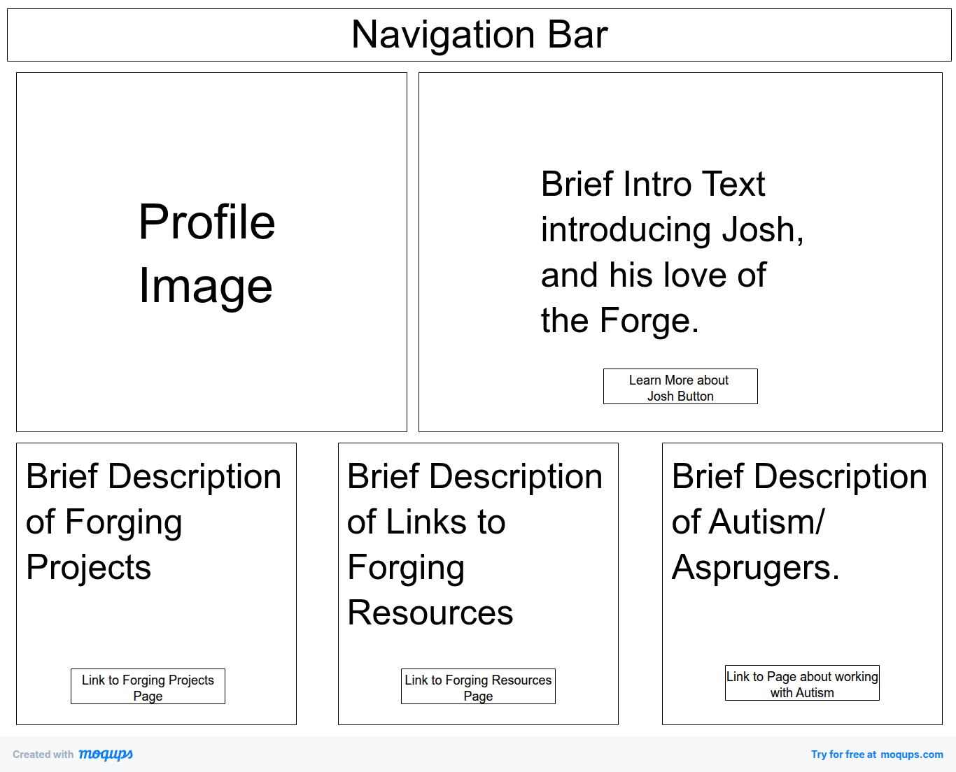

About Page
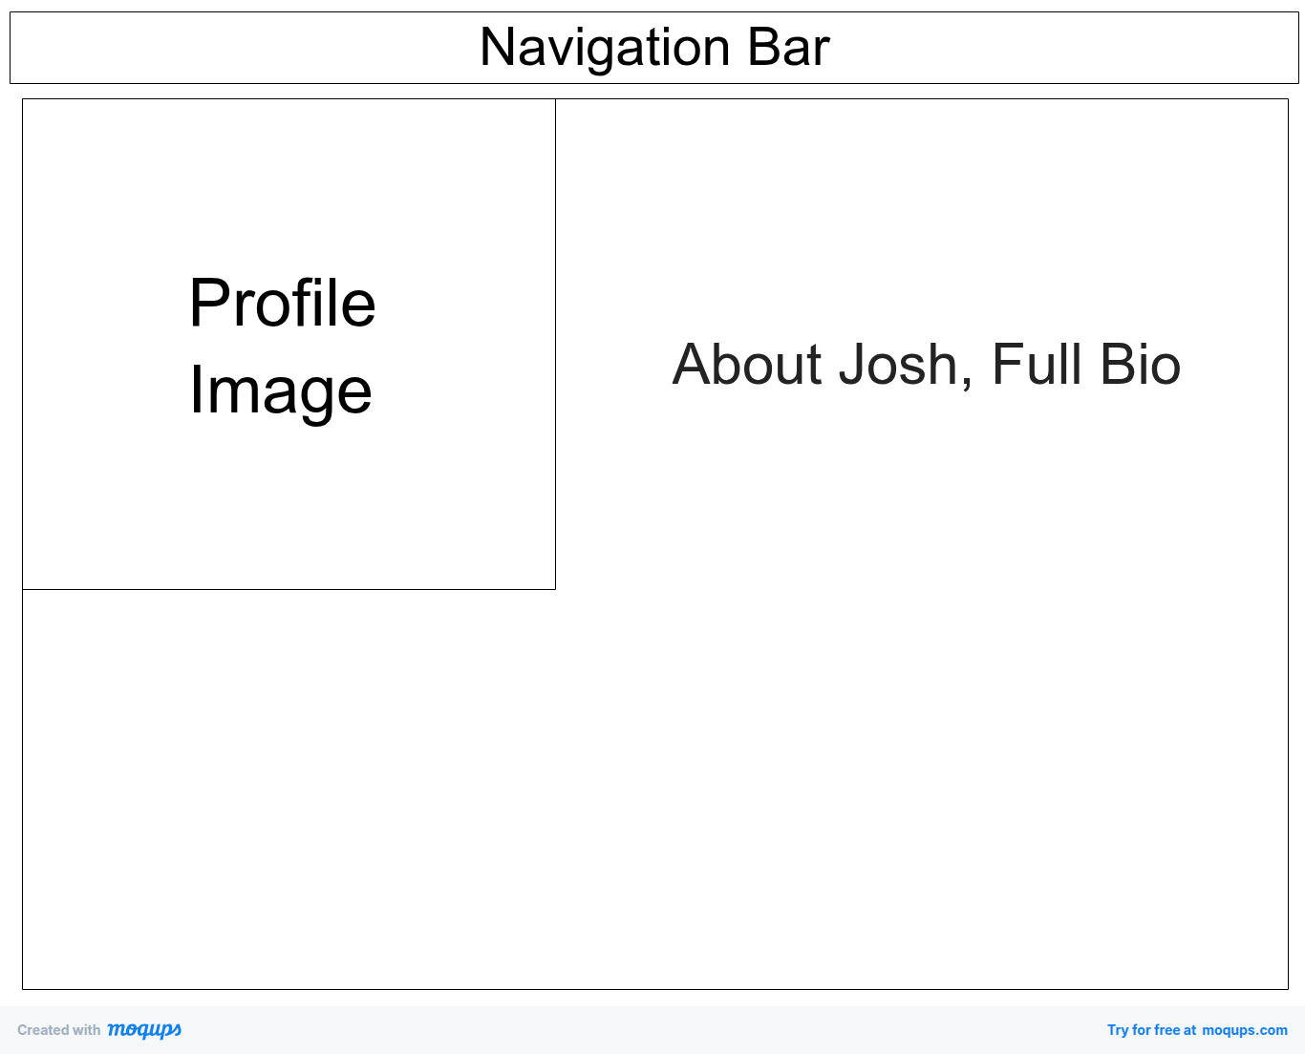

Crafts/Hobbies Page
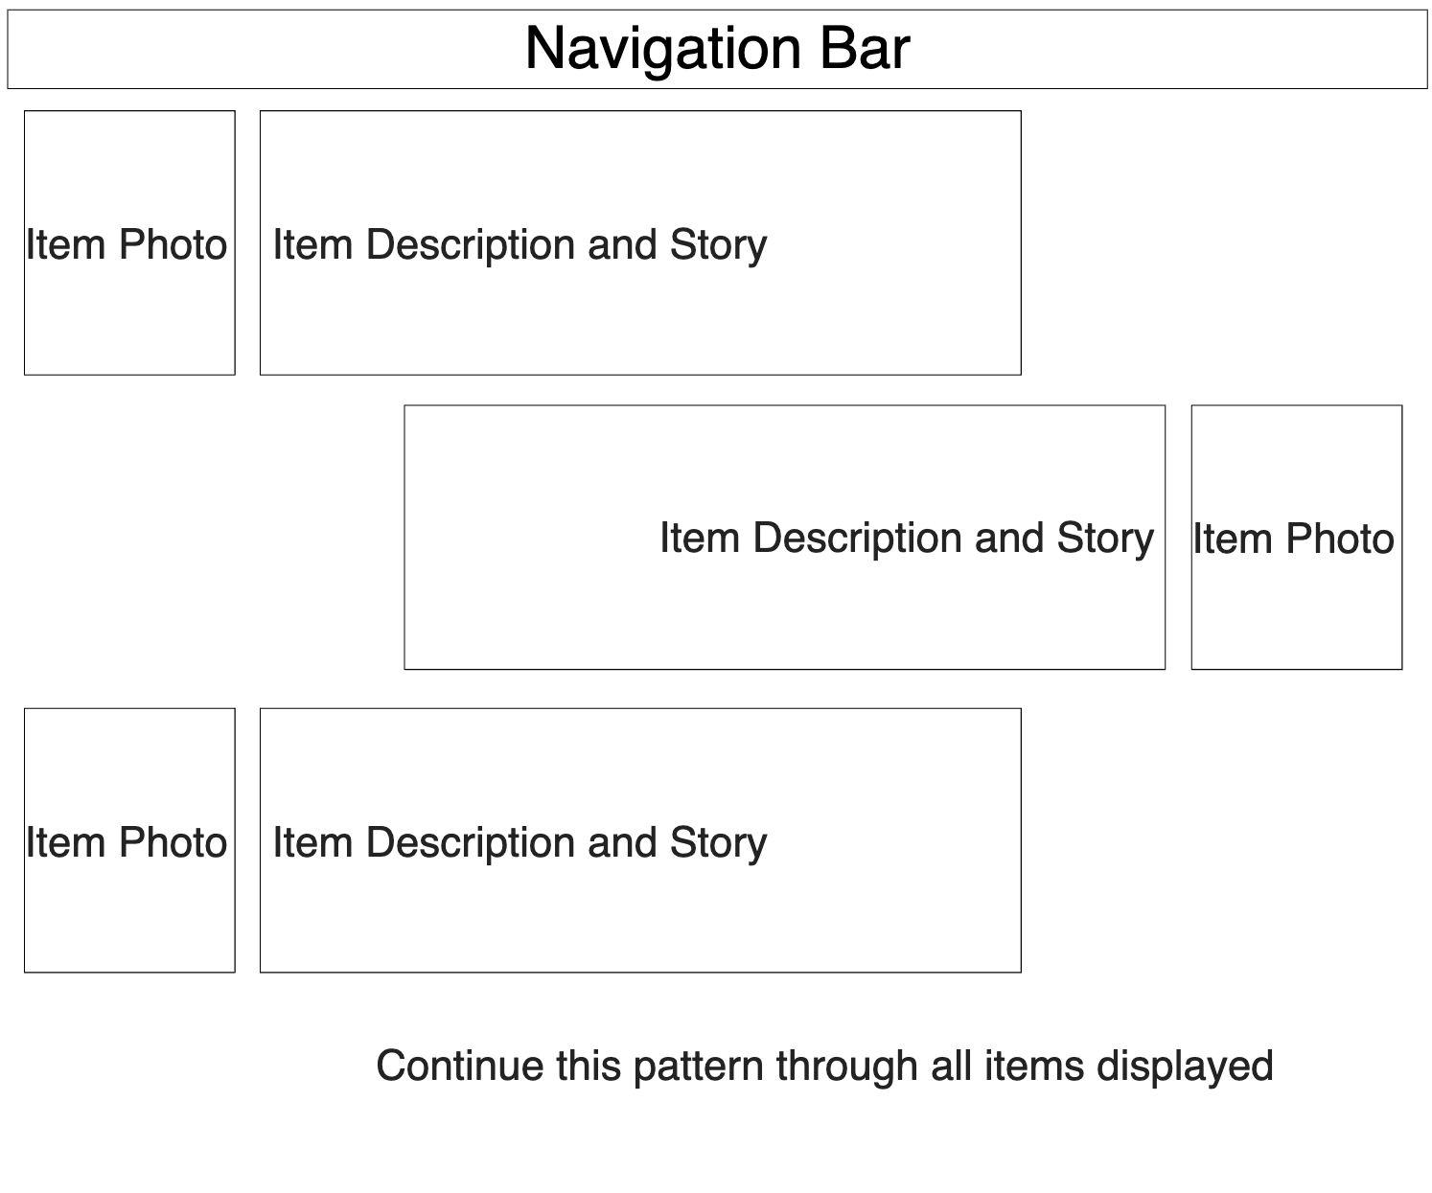

Forging Resources Page

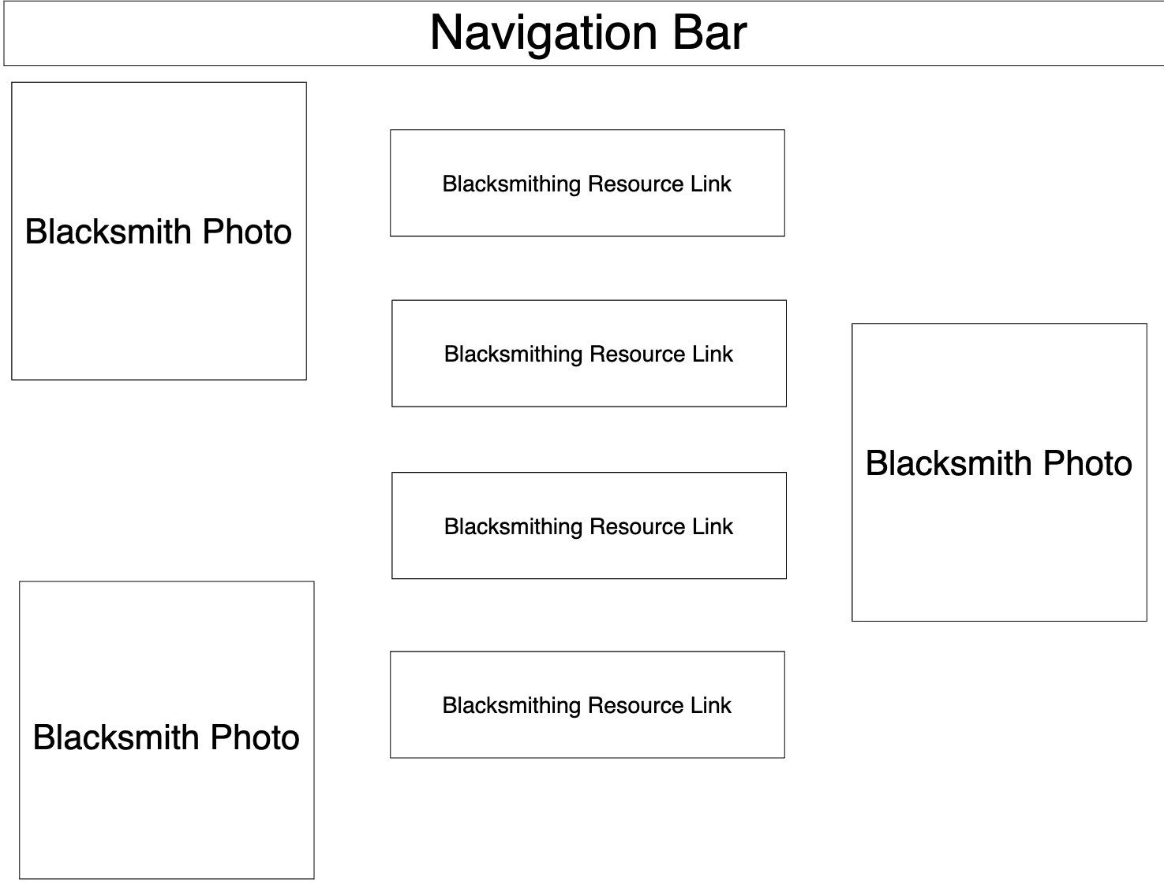

Working with Autism Page

